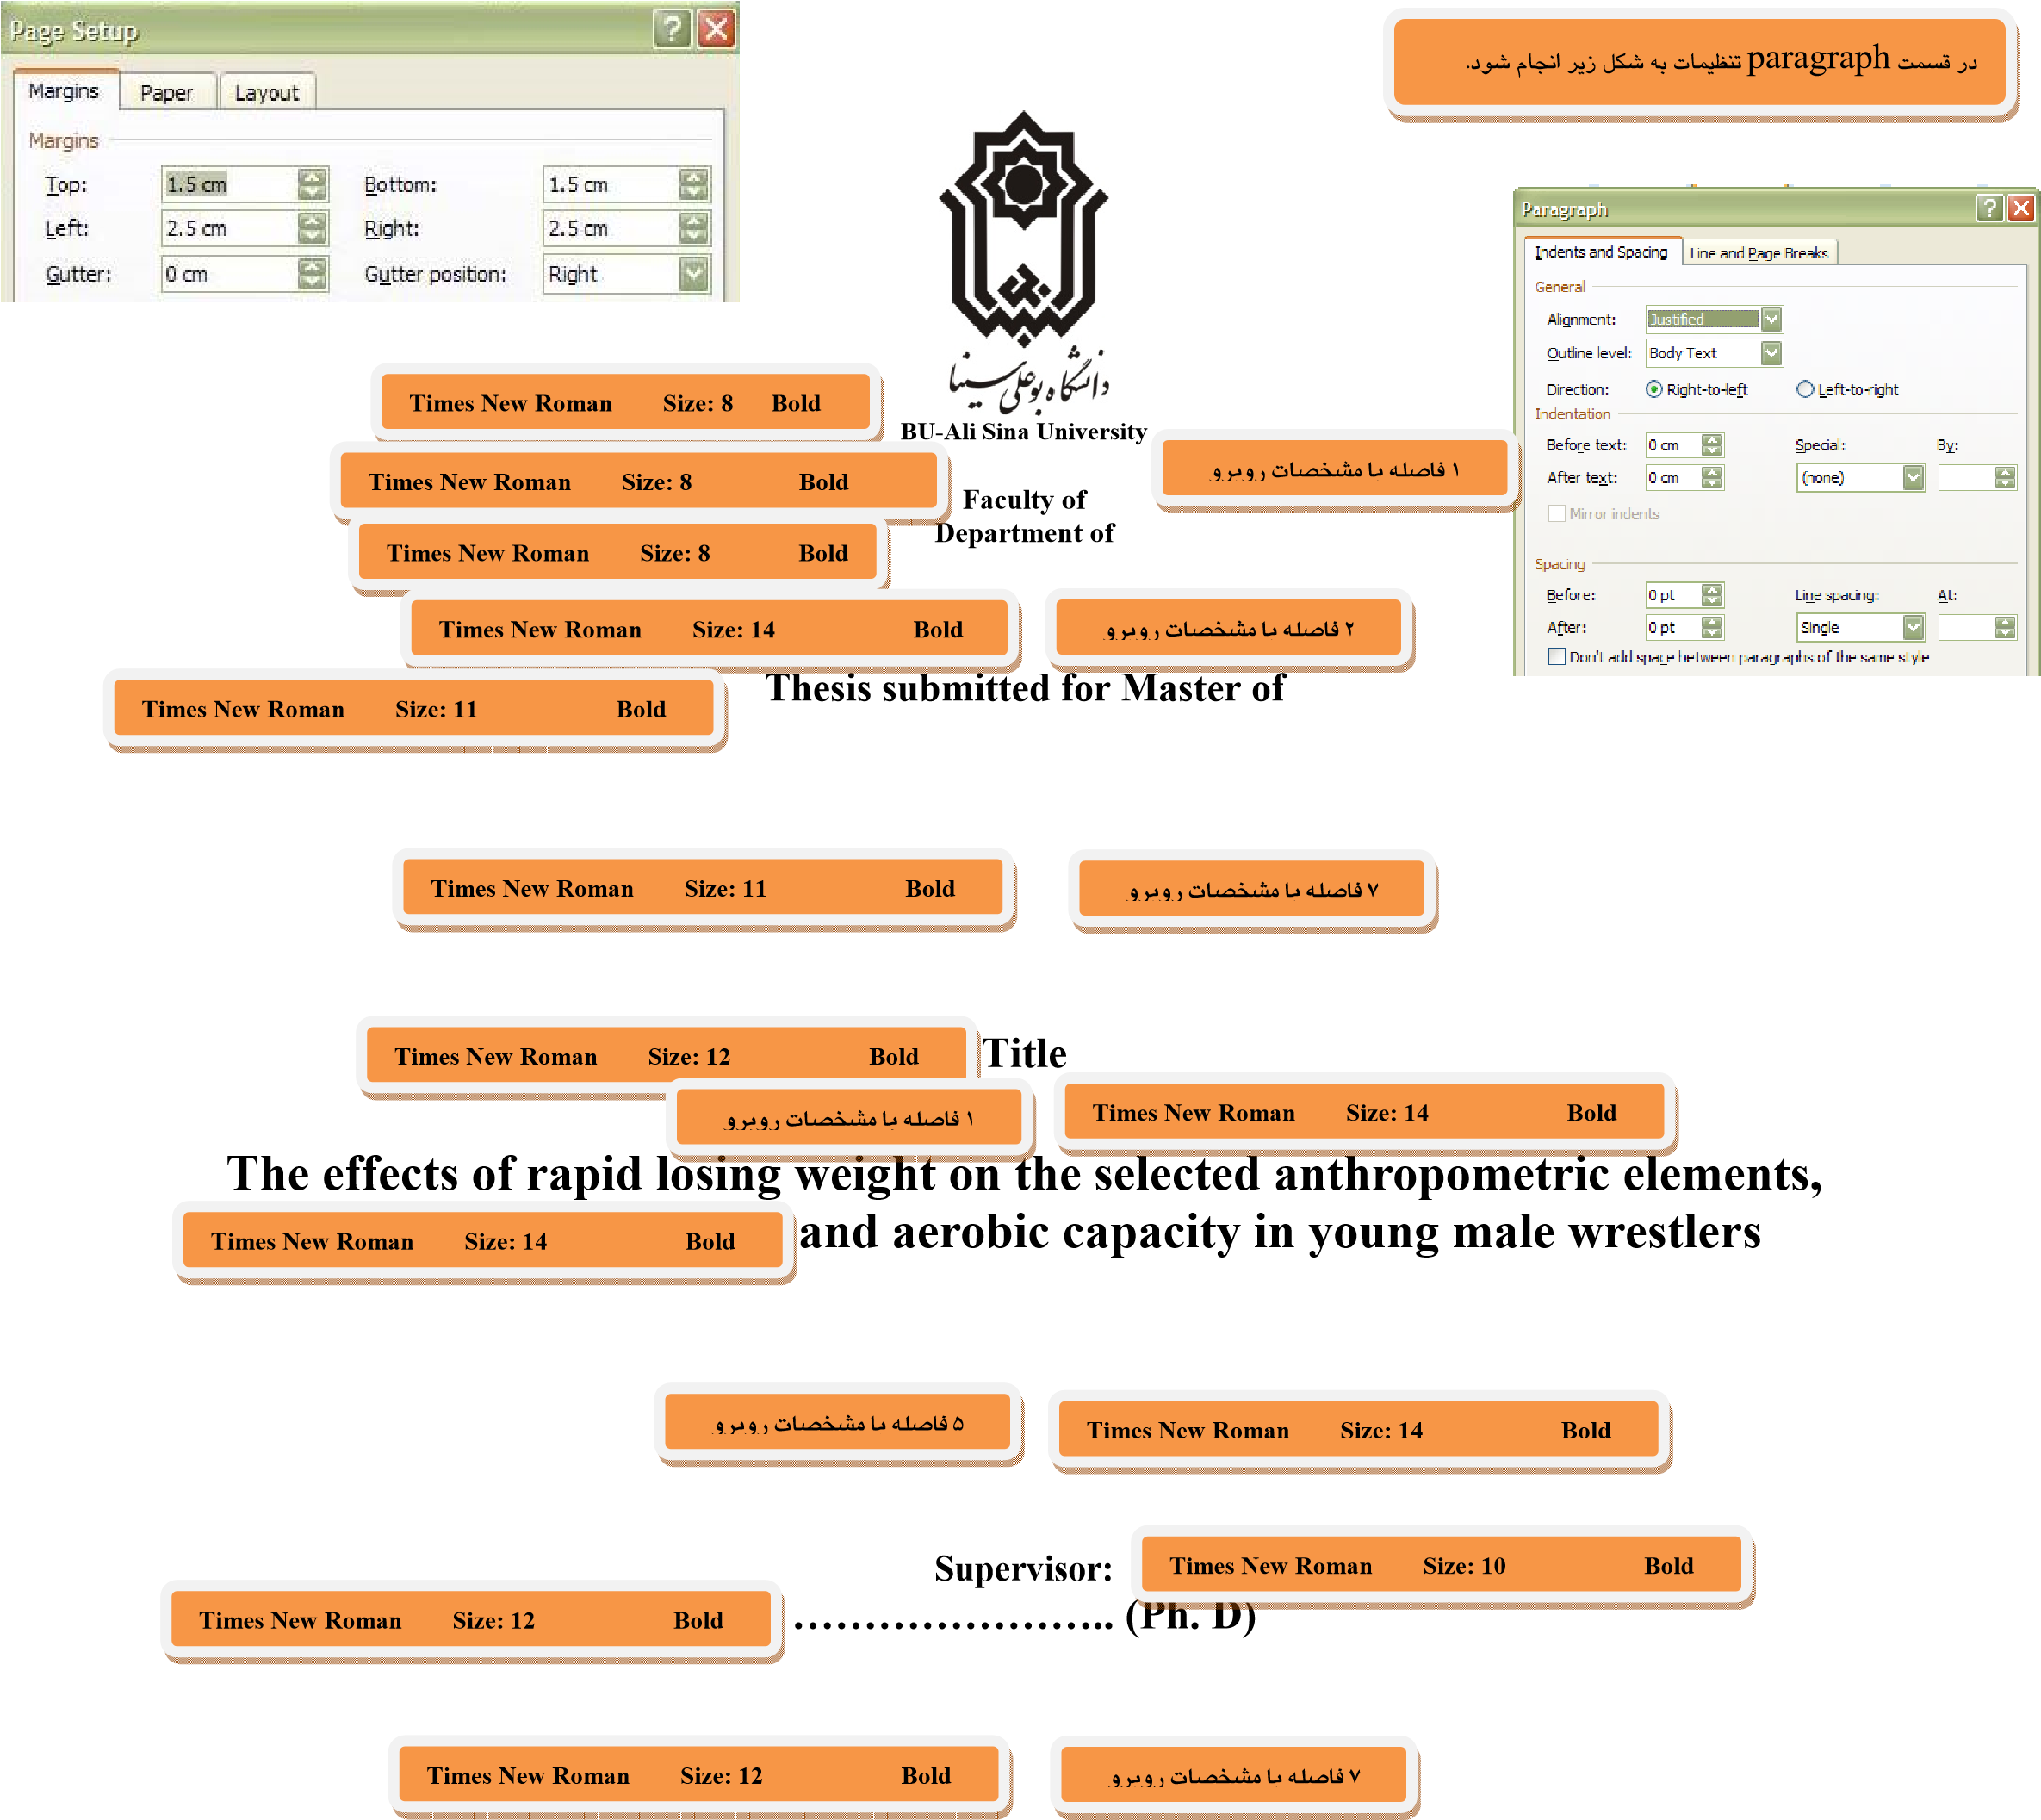


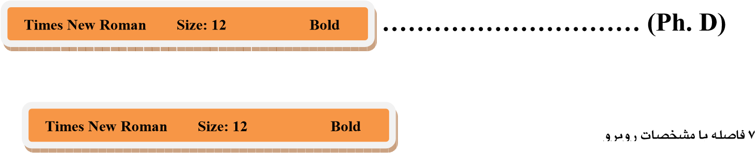

Advisor: Times New Roman Size: 10 Bold

